POTENTIAL PROJECT APPLICATION 2021
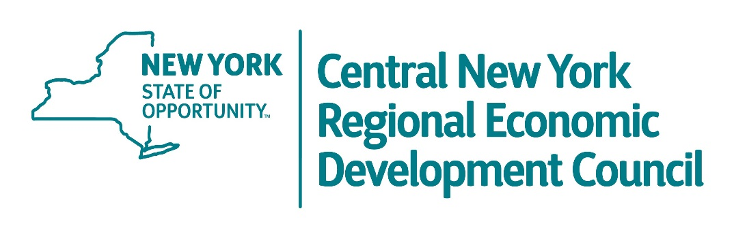

Applicant Information
Full Name:
 | First | Last
Company Name:
Position at Company:
Phone Number: | ( ) | Email Address:

City or Town/County:

Project Information
Describe Potential Project In One Sentence:
Describe Potential Project In Full:

Project Details

Anticipated Start: |  | Anticipated Finish:

Total Project Cost: | $ | Total Funding Requested: | $

# Jobs Created: |  | # Jobs Retained:

Have you ever received funding through NYS or the Consolidated Funding Application? (Y/N)
If Yes, Explain:

Describe how your project fits into the REDC Strategy:

Please returned completed forms no later than April 30th to:

Daniel Kolinski
Deputy Director, Central New York Region
Daniel.Kolinski@esd.ny.gov

MAIL
Empire State Development
620 Erie Boulevard West, Suite 112
Syracuse, New York 13204

Fax: 315.425-7156

